**Chapter 4**

**System Design**

# System Design

There are three things in the game which are graphics of the game, the sound of game and input command. The game engine renders all the graphics of the game and in our case it is unity 3D. And the command input is from the user who is playing the game.

## System Architecture Diagram

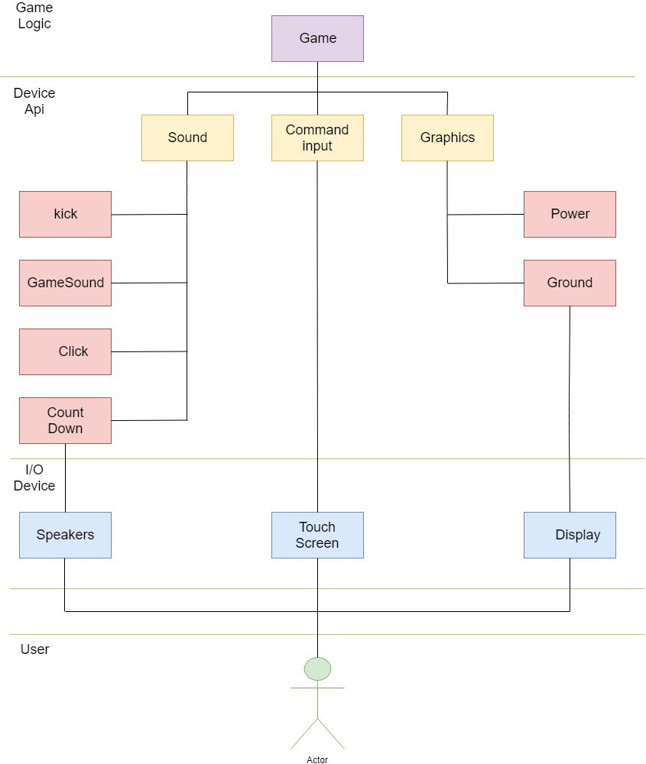

# ERD

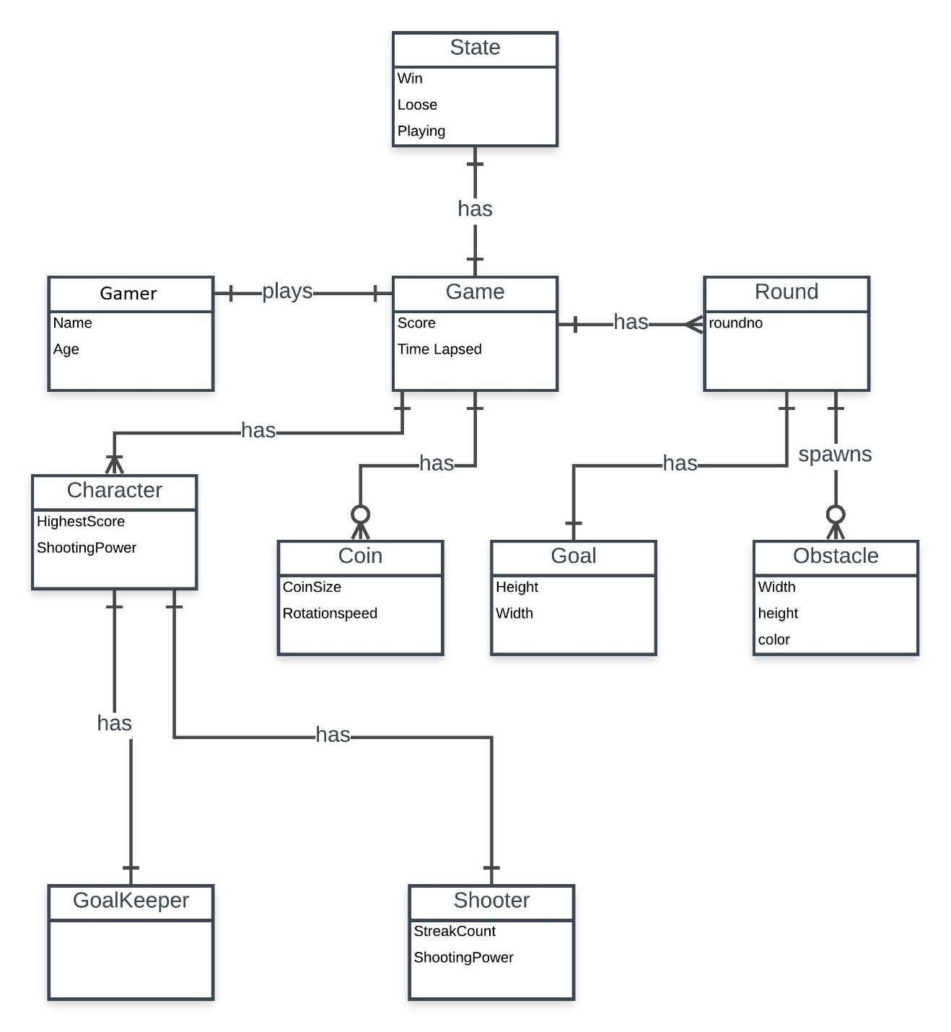

**Entity Relationship Diagram**

Figure 20 shows the ERD of game which shows the inheritence relation with other entities. State inherit the game and game associate the round and gamer. Gamer inherit character,coins,goal and obstacle. Character inherit the goalkeeper and shooter. All the relations are made to develop database for game.

# Class Diagram

## 

**class Diagram**

Figure 10 shows the class diagram of Soccer bash game. It shows the state and state have many composition inheritance with game which associate gamer and round. Game have decomposition relation with other game nouns such as character, coin, goal and obstacles. Character have two more relation Goalkeeper and shooter.

# Sequence Diagram

1. **Main Menu**

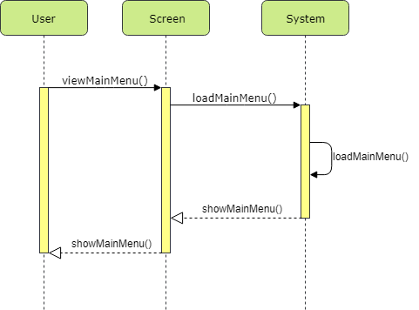

**Sequence Diagram main menu**

Figure 11 shows the sequence diagram for main menu. User touch the screen and main menu will load. After loading the main menu back response generate that will be output.

1. **Settings**

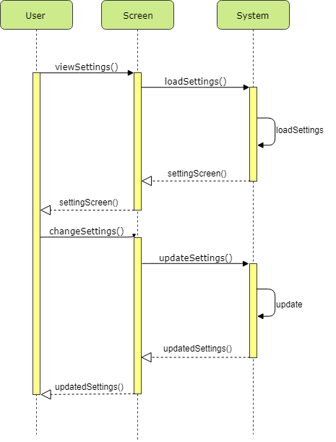

**Sequence Diagram Settings**

As shown in figure 12 you can see the sequence diagram of the settings of game. You will go to the settings screen from the main menu to load it and then settings screen shows up. Now you can send the command of update settings as you wish according to your need and it will update the settings as you commanded it.

1. **Character Selection**

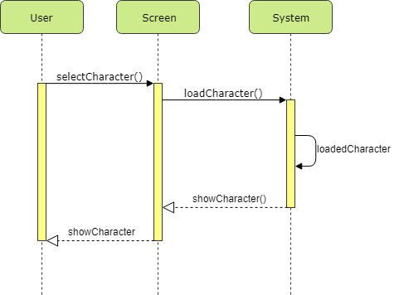

**Sequence Diagram character selection**

As shown in figure 13, you can see the sequence diagram for the character selection use case. From the character selection window you will select your character and it will send a request to select the character as the one you selected and then it will show you the character you selected in the response of your request.

1. **Check Profile**

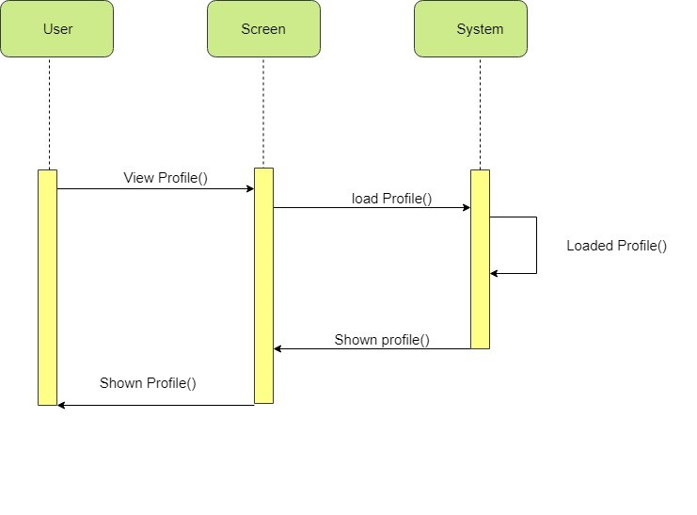

**Sequence Diagram check profile**

Figure 14 shows the check profile sequence diagram when user click on profile then the details of user will show. When user clicks then requests goes and file load for profile on system and back response goes back to user and profile will show to user.

1. **Pause game**

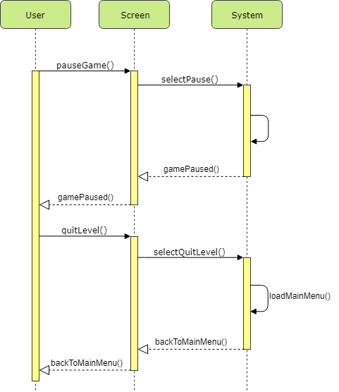

**Sequence Diagram Pause game**

As shown in figure 5.4, you can see the sequence diagram for pause game. When you send the request to pause the game, the system process the request and in return it pause the game.

1. **Start Career**

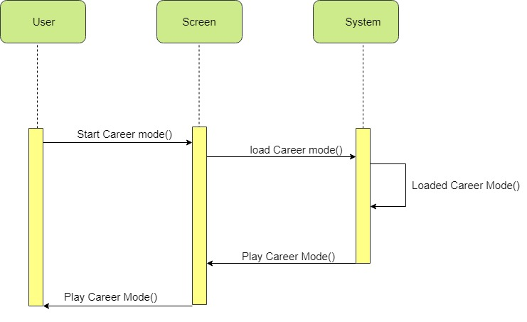

**Sequence Diagram Start career**

Figure 16 shows start career sequence diagram which shows when user click on career mood then start career mood request goes to system and loaded the file and this request goes back to user and play area screen shows as an output.

1. **Contact Us**

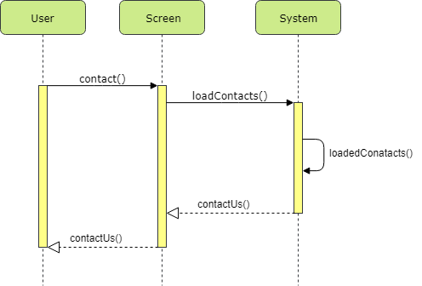

**Sequence Diagram contact us**

Figure 17 shows the sequence diagram of contact us functionality which shows user the email ID when user face any problem for this purpose sequence diagram shows steps of commands when user clicks request goes to screen and load the contact screen then results shown to user.

1. **Quit Level**

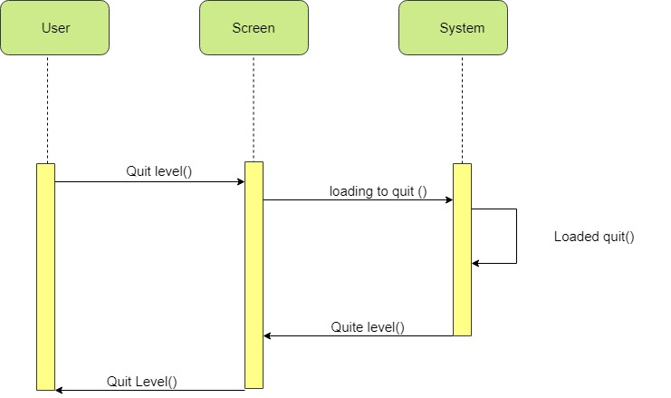

**Sequence Diagram quit level**

As shown in figure 18 you can see the sequence diagram of the Quit level feature in the game. To quit the game you have to pause the game first if you are playing the game. When you send the request for pause game, the system will pause it and after that the screen will show up where either you can quit or you can resume and if you select quit game then the system process the request and take you back to main menu.

1. **GetHelp**

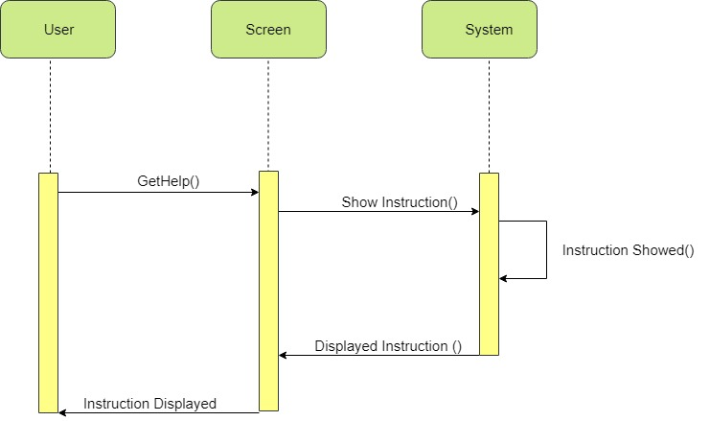

**Sequence Diagram get help**

Get help sequence diagarm shown by figure 19 which shows the tips and other all other easy to get maximum coins. For this that sequence diagram shows the steps how the process will be accomplish.

# Data Flow Diagram

**Data Flow Diagram Level 0:**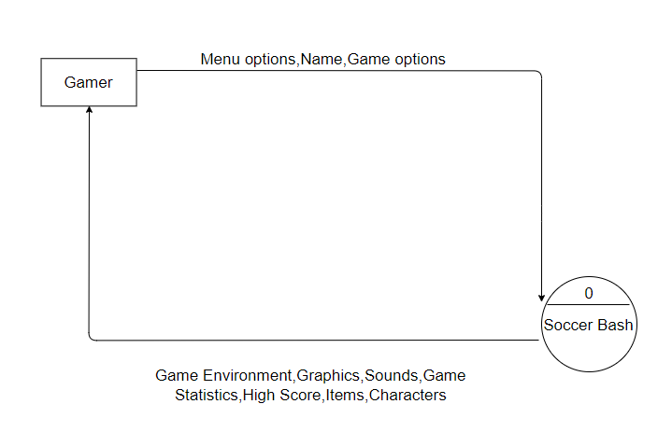

**Data Flow Diagram Level 0**

Figure 7 shows DFD level 0. DFD level 0 shows the game and entity relationship (user). There is only one entity which is gamer or user. And other certain things shown on flow arrow.

**Data Flow Diagram Level 1:**

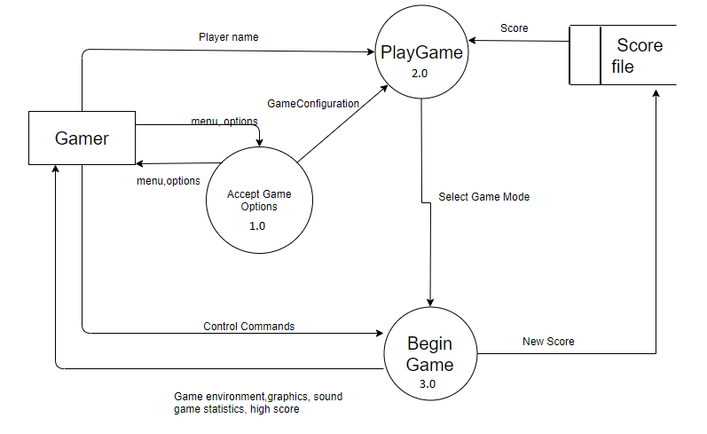

**Data Flow Diagram Level 2:**

Figure 8 shows the DFD level 1 diagram. DFD 1 shows the game play into smaller process and showing the relation with entities. It also shows the database where is it necessary such as to record the data of user (User name, score etc.). After selecting the game options user will select the level and enter into game.

**Activity Diagram**

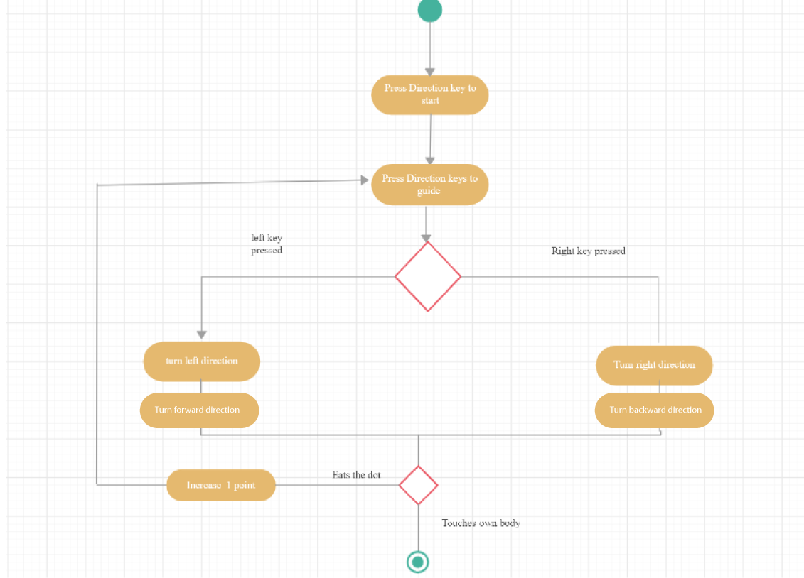

**Domain Model**

